Program: Android App on Wardrobe Management

Function design:
Wardrobe is an app that integrates the functions of wardrobe management, design and sharing of the match of dressing.
Its main functions include:
(1) A list of the clothes with complete information (location, price, brand, etc.);
(2) Classification of clothes, based on category, season and color;
(3) Photo-recordings of the match of their clothes and upload the information to the community;
(4) Browse of other people's match of clothes in the community, and follow the users who have the same excellent clothing style as you;
(5) Access to personalized recommendation and Dressing Guide on the homepage;
Technology involved: Back end database design, implementation and management; Front end design and implementation, android network-end interaction;

UI Interface:
My App has four pages: Closet, Home, Community and Settings. The Home page shows the weather (at the top of the page) and news selected from the community (at the middle of the page). Information at the Home page can assist users decide what to wear can how to wear them today. The Closet page displays the catalogue the users set for their clothes. You can see the list of the kinds of the clothes on the left of the page and pictures of those clothes on the right of the page. The Community page presents pictures users upload. This is the place where people can share their dress collocation. The setting page is where users can get help and feedback. What’s more, the users can click the plus button at any pages to upload a photo of their cloth to the Closet.
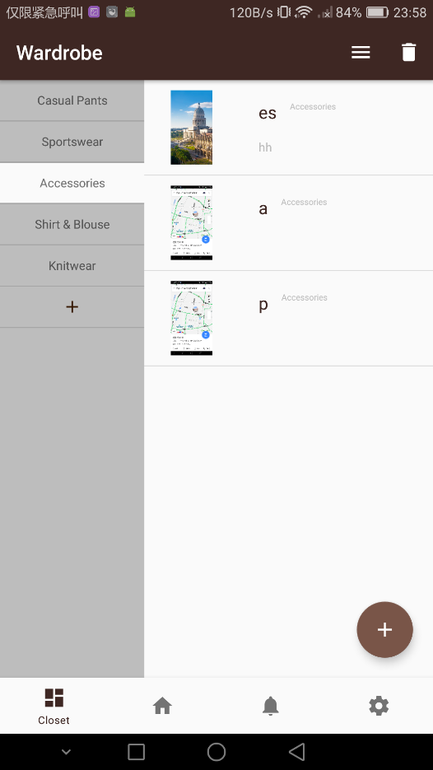
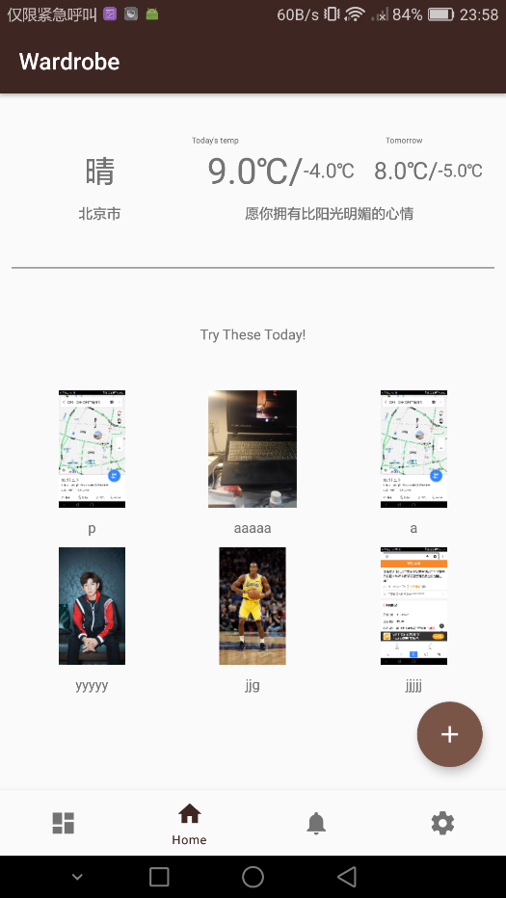

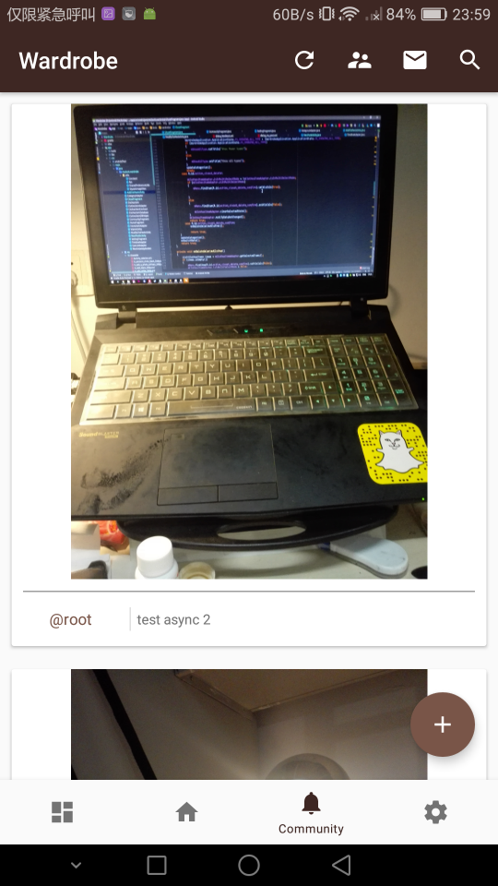
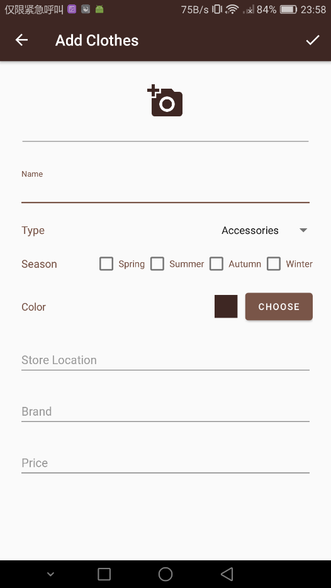

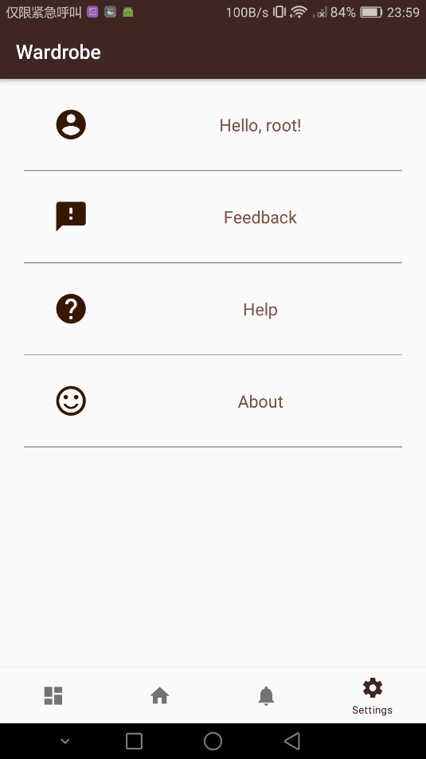
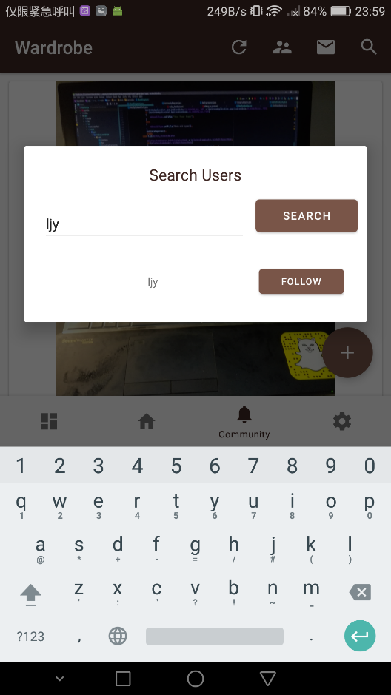

Clarification:
One thing to be clarified: some of the photos showed above don’t contain pictures of clothes, because our group was testing the upload function of the APP. We just randomly uploaded some pictures.

